Switzerland
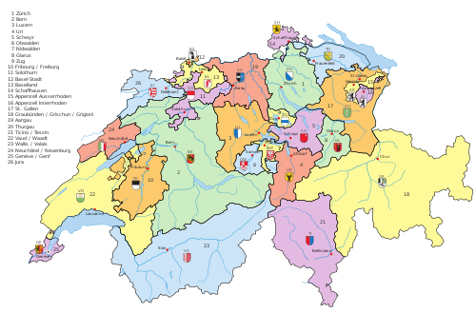
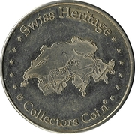
Chronology
1 Aug 1291 Swiss Confederation founded (Uri, Schwyz, and
Unterwalden), called forest states (Waldstätten).
(no central executive authority, each canton
retains sovereignty and feudal rights)
(see separate cantons).
15 Nov 1315 Swiss troops defeat the Austrians under Leopold I
of Habsburg at the Battle of Morgarten.
19 Jul 1318 Habsburgs relinquish suzerainty (by cease-fire
agreement) over the Waldstätten.
22 Sep 1499 The Holy Roman Emperor recognizes the de facto
independence of the Swiss Confederation.
8 Feb 1649 Peace of Westphalia treaties go into effect
recognizing the sovereign independence of the
full members of the Swiss Confederation.
5 Mar 1798 - Aug 1802 French occupation.
12 Apr 1798 Helvetic Republic (Helvetische Republik/République
Helvétique); proclamation of independence of the
Swiss nation and the establishment of one,
indivisible, democratic and representative
republic are approved by the Senate and Grand
Council, representing 10 cantons, at the sessions
held in Aargau (abolition of cantonal sovereignty
and feudal rights).
12 Apr 1798 - 29 Dec 1813 French protectorate.
27 May 1799 - Dec 1799 Austro-Russian invasion.
29 May 1801 Constitution adopted (effective 28 Oct 1801 by Loi).
2 Jul 1802 Constitution adopted (by Beschluss des Kleinen
Raths).
28 Aug 1802 - 3 Oct 1802 Civil war (Stecklikrieg).
15 Oct 1802 - 9 Jan 1804 French re-occupation.
10 Mar 1803 Swiss Confederation¹ (Confédération Suisse/
Schweizerische Eidgenossenschaft/Confederazione
Svizzera/(from 29 Apr 1939, Confederaziun Svizra)
[Latin, in limited official use without
Constitutional status: Confoederatio Helvetica])
re-established by 19 Feb 1803 Acte de Médiation/
Vermittlungsacte (cantonal sovereignty partially
restored).
29 Dec 1813 Constitution voided by arrangement (Übereinkunft).
7 Aug 1815 Federal pact (Bundesvertrag) is signed by the
representatives of 22 cantons of Switzerland in
Zürich.
20 Nov 1815 Allied powers formally accept the neutrality
of Switzerland by Congress of Vienna final act.
17 Mar 1832 Siebnerkonkordat signed by the liberal cantons
(Luzern, Zürich, Bern, Solothurn, St. Gallen,
Aargau, and Thurgau) as a united front against
the conservative cantons.
15 Nov 1832 - 12 Aug 1833 Sarnerbund formed by the conservative cantons in
response to the liberal Siebnerkonkordat (by
Uri, Schwyz, Obwalden, Nidwalden, Neuchâtel, and
Basel-Stadt), it is dissolved by liberal cantons.
11 Dec 1845 - 1 Dec 1847 Sonderbund formed by conservative Catholic cantons
(Luzern, Uri, Schwyz, Unterwalden, Zug, Fribourg,
and Valais) in opposition to liberal Protestant
cantons, leading to a brief civil war which is
won by the liberal cantons. The Sonderbund
military is led by Johann Ulrich von Salis-Soglio
(b. 1790 - d. 1874), Oct - 26 Nov 1847, as
commander-in-chief.
20 Nov 1848 Federal constitution effective (adopted 12 Sep
1848).
29 May 1874 Constitution effective (adopted 1 Jan 1874).
29 Apr 1939 German, French, Italian, and Rhaeto-Romansh made
national languages; German, French, Italian made
official languages by enactment of Constitutional
amendment.
6 Dec 1992 In referendum Swiss voters reject European Economic
Area membership, 50.3% to 49.7%.
8 Jun 1997 In referendum Swiss voters reject accession talks
with the European Union, 74.1% to 25.9%.
1 Jan 2000 Constitution effective (adopted 18 Dec 1998).
4 Mar 2001 In referendum Swiss voters reject European Union
membership, 76.8% to 23.2%.
 | Presidents of the Executive Directory
 | 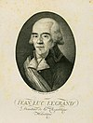 | 22 Apr 1798 - 31 May 1798 Johann Lukas Legrand (b. 1755 - d. 1836)
 | 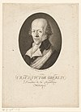 | 1 Jun 1798 - 1 Jul 1798 Urs Viktor Oberlin (1st time) (b. 1747 - d. 1818)
 | 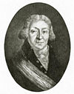 | 2 Jul 1798 - 31 Jul 1798 Pierre Maurice Glayre (1st time) (b. 1743 - d. 1819)
 | 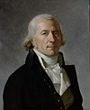 | 1 Aug 1798 - 31 Aug 1798 Frédéric César de La Harpe  (1st time) (b. 1754 - d. 1838)
 | 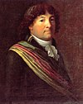 | 1 Sep 1798 - 30 Sep 1798 Peter Ochs (1st time) (b. 1752 - d. 1821)
1 Oct 1798 - 21 Nov 1798 Frédéric César de La Harpe
(2nd time) (s.a.)
 |  | 22 Nov 1798 - 12 Jan 1799 Urs Viktor Oberlin (2nd time) (s.a.)
 |  | 13 Jan 1799 - 5 Mar 1799 Pierre Maurice Glayre (2nd time) (s.a.)
 | 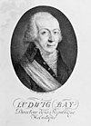 | 6 Mar 1799 - 26 Apr 1799 David Ludwig Bay (b. 1749 - d. 1832)
 |  | 27 Apr 1799 - 23 Jun 1799 Peter Ochs (2nd time) (s.a.)
24 Jun 1799 - 4 Sep 1799 Frédéric César de La Harpe
(3rd time) (s.a.)
 |  | 5 Sep 1799 - 17 Nov 1799 François Pierre Savary (b. 1750 - d. 1821)
 | 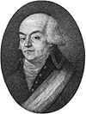 | 18 Nov 1799 - 7 Jan 1800 Johann Rudolf Dolder (b. 1753 - d. 1807)
 | President of the Provisional Executive Power
 |  | 7 Jan 1800 - 11 Jan 1800 Johann Rudolf Dolder (s.a.)
 | Presidents of the Provisional Executive Commission
 |  | 12 Jan 1800 - 27 May 1800 Johann Rudolf Dolder (s.a.)
 |  | 28 May 1800 - 25 Jun 1800 Karl Albrecht Frisching (b. 1734 - d. 1801)
 |  | 26 Jun 1800 - 23 Jul 1800 François Pierre Savary (s.a.)
 |  | 24 Jul 1800 - 8 Aug 1800 Johann Konrad Finsler (b. 1765 - d. 1839)
 | Presidents of the Provisional Executive Council
 |  | 9 Aug 1800 - 30 Sep 1800 Karl Albrecht Frisching (1st time) (s.a.)
 |  | 1 Oct 1800 - 31 Oct 1800 Johann Rudolf Dolder (1st time) (s.a.)
1 Nov 1800 - 30 Nov 1800 Karl Friedrich Zimmermann
(1st time) (b. 1765 - d. 1823)
 |  | 1 Dec 1800 - 31 Dec 1800 Johann Jakob Schmid (1st time) (b. 1765 - d. 1828)
 | 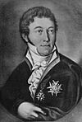 | 1 Jan 1801 - 31 Jan 1801 Vinzenz Rüttimann (1st time) (b. 1769 - d. 1844)
 |  | 1 Feb 1801 - 28 Feb 1801 François Pierre Savary (1st time) (s.a.)
 |  | 1 Mar 1801 - 31 Mar 1801 Karl Albrecht Frisching (2nd time) (s.a.)
 |  | 1 Apr 1801 - 30 Apr 1801 Johann Rudolf Dolder (2nd time) (s.a.)
1 May 1801 - 31 May 1801 Karl Friedrich Zimmermann
(2nd time) (s.a.)
 |  | 1 Jun 1801 - 30 Jun 1801 François Pierre Savary (2nd time) (s.a.)
 |  | 1 Jul 1801 - 31 Jul 1801 Johann Jakob Schmid (2nd time) (s.a.)
 |  | 1 Aug 1801 - 31 Aug 1801 Vinzenz Rüttimann (2nd time) (s.a.)
 | 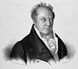 | 1 Sep 1801 - 30 Sep 1801 Paulus Usteri (b. 1768 - d. 1831)
 |  | 1 Oct 1801 - 27 Oct 1801 Johann Rudolf Dolder (3rd time) (s.a.)
 | President of the Provisional Executive
 |  | 28 Oct 1801 - 22 Nov 1801 Johann Rudolf Dolder (s.a.)
 | Erster Landammann/Premier Landamman
 | 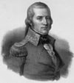 | 23 Nov 1801 - 6 Feb 1802 Aloys Reding von Biberegg (b. 1765 - d. 1818)
 | Landammänner/Landammans
 |  | 6 Feb 1802 - 20 Apr 1802 Aloys Reding von Biberegg (s.a.)
 |  | 20 Apr 1802 - 5 Jul 1802 Vinzenz Rüttimann (acting) (s.a.)
 |  | 5 Jul 1802 - 8 Mar 1803 Johann Rudolf Dolder (s.a.)
 | Heads of the Confederation (the chief magistrates of the canton hosting the Diet), with the title Landammann der Schweiz/Landamman de la Suisse/Landamano della Svizzera
 | 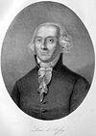 | 10 Mar 1803 - 31 Dec 1803 Louis d'Affry (1st time) (b. 1743 - d. 1810)
 | 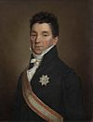 | 1 Jan 1804 - 31 Dec 1804 Niklaus Rudolf von Wattenwyl  (1st time) (b. 1760 - d. 1832)
1 Jan 1805 - 31 Dec 1805 Peter Josef Johann Anton von
Glutz-Ruchti
(b. 1754 - d. 1835)
 | 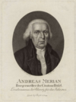 | 1 Jan 1806 - 31 Dec 1806 Andreas Merian  (b. 1742 - d. 1811)
 | 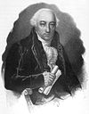 | 1 Jan 1807 - 31 Dec 1807 Hans von Reinhard (1st time) (b. 1755 - d. 1835)
 |  | 1 Jan 1808 - 31 Dec 1808 Vinzenz Rüttimann (1st time) (s.a.)
 |  | 1 Jan 1809 - 31 Dec 1809 Louis d'Affry (2nd time) (s.a.)
1 Jan 1810 - 31 Dec 1810 Niklaus Rudolf von Wattenwyl
(2nd time) (s.a.)
1 Jan 1811 - 31 Dec 1811 Heinrich Daniel Balthasar Josef
Grimm von Wartenfels (b. 1754 - d. 1821)
 | 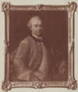 | 1 Jan 1812 - 31 Dec 1812 Peter Burckhardt  (b. 1742 - d. 1817)
 |  | 1 Jan 1813 - 31 Dec 1813 Hans von Reinhard (2nd time) (s.a.)
 |  | Presidents of the Diet
 |  | 6 Apr 1814 - 1814 Hans von Reinhard (1st time) (s.a.)
 | 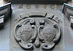 | 24 Jun 1814 - 12 Dec 1814 Hans Konrad von Escher vom Luchs (b. 1743 - d. 1814)
 |  | 12 Dec 1814 - 21 Dec 1814 Johann Konrad Finsler (interim) (s.a.)
 | 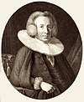 | 21 Dec 1814 - 31 Dec 1815 David von Wyss II (1st time) (b. 1763 - d. 1839)
 |  | 1 Jan 1816 - 31 Dec 1816 Hans von Reinhard (2nd time) (s.a.)
1 Jan 1817 - 31 Dec 1817 Niklaus Rudolf von Wattenwyl
(1st time) (s.a.)
 | 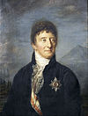 | 1 Jan 1818 - 31 Dec 1818 Niklaus Friedrich von Mülinen  (1st time) (b. 1760 - d. 1833)
 | 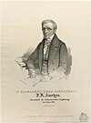 | 1 Jan 1819 - 31 Dec 1819 Josef Karl Xaver Leopold Leodegar Amrhyn (1st time) (b. 1777 - d. 1848)
 |  | 1 Jan 1820 - 31 Dec 1820 Vinzenz Rüttimann (2nd time) (s.a.)
 |  | 1 Jan 1821 - 31 Dec 1821 David von Wyss II (2nd time) (s.a.)
 |  | 1 Jan 1822 - 31 Dec 1822 Hans von Reinhard (3rd time) (s.a.)
1 Jan 1823 - 31 Dec 1823 Niklaus Rudolf von Wattenwyl
(2nd time) (s.a.)
1 Jan 1824 - 31 Dec 1824 Niklaus Friedrich von Mülinen
(2nd time) (s.a.)
 |  | 1 Jan 1825 - 31 Dec 1825 Josef Karl Xaver Leopold Leodegar Amrhyn (2nd time) (s.a.)
1 Jan 1826 - 31 Dec 1826 Vinzenz Rüttimann
(3rd time) (s.a.)
1 Jan 1827 - 31 Dec 1827 David von Wyss II
(3rd time) (s.a.)
1 Jan 1828 - 31 Dec 1828 Hans von Reinhard
(4th time) (s.a.)
1 Jan 1829 - 31 Dec 1829 Niklaus Rudolf von Wattenwyl
(3rd time) (s.a.)
 | 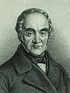 | 1 Jan 1830 - 31 Dec 1830 Emanuel Friedrich von Fischer (b. 1786 - d. 1870)
 |  | 1 Jan 1831 - 31 Dec 1831 Josef Karl Xaver Leopold Leodegar Amrhyn (3rd time) (s.a.)
 |  | 1 Jan 1832 - 31 Dec 1832 Eduard Pfyffer von Altishoven (b. 1782 - d. 1834)
 | 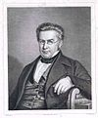 | 1 Jan 1833 - 31 Dec 1833 Johann Jakob Hess (1st time) (b. 1791 - d. 1854)
 | 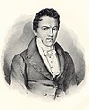 | 1 Jan 1834 - 31 Dec 1834 Konrad Melchior Hirzel (b. 1793 - d. 1843)
 |  | 1 Jan 1835 - 31 Dec 1835 Franz Karl von Tavel (b. 1801 - d. 1865)
1 Jan 1836 - 31 Dec 1836 Karl Friedrich Tscharner
(1st time) (b. 1772 - d. 1844)
 |  | 1 Jan 1837 - 31 Dec 1837 Josef Karl Xaver Leopold Leodegar Amrhyn (4th time) (s.a.)
 | 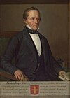 | 1 Jan 1838 - 31 Dec 1838 Georg Jakob Kopp (b. 1786 - d. 1859)
 |  | 1 Jan 1839 - 31 Dec 1839 Johann Jakob Hess (2nd time) (s.a.)
 |  | 1 Jan 1840 - 31 Dec 1840 Johann Konrad von Muralt (b. 1779 - d. 1869)
 | 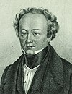 | 1 Jan 1841 - 31 Dec 1841 Johann Karl Friedrich Neuhaus (b. 1796 - d. 1849)
1 Jan 1842 - 31 Dec 1842 Karl Friedrich Tscharner
(2nd time) (s.a.)
 |  | 1 Jan 1843 - 31 Dec 1843 Rudolf Rüttimann
 | 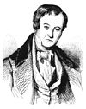 | 1 Jan 1844 - 31 Dec 1844 Konstantin Siegwart-Müller (b. 1801 - d. 1869)
 |  | 1 Jan 1845 - 2 Apr 1845 Johann Heinrich Emmanuel Mousson (b. 1803 - d. 1869)
 | 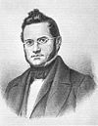 | 2 Apr 1845 - 31 Dec 1845 Jonas Furrer (b. 1805 - d. 1861)
 | 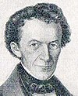 | 1 Jan 1846 - 31 Dec 1846 Johann Ulrich Zehnder (b. 1798 - d. 1877)
 | 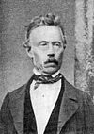 | 1 Jan 1847 - 28 May 1847 Alexander Ludwig Funk (1st time) (b. 1806 - d. 1871)
 | 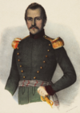 | 28 May 1847 - 5 Nov 1847 Ulrich Ochsenbein (1st time) (b. 1811 - d. 1890)
 | 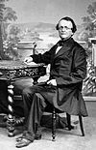 | 5 Nov 1847 - 2 Dec 1847 Johann Rudolf Schneider (acting) (b. 1804 - d. 1880)
 |  | 2 Dec 1847 - 31 May 1848 Ulrich Ochsenbein (2nd time) (s.a.)
 |  | 31 May 1848 - 20 Nov 1848 Alexander Ludwig Funk (2nd time) (s.a.)
 | Presidents
21 Nov 1848 - 31 Dec 1849 Jonas Furrer
(1st time) FDP (s.a.)
 | 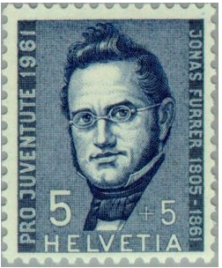
 | 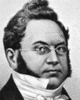 | 1 Jan 1850 - 31 Dec 1850 Henri Druey FDP  (b. 1799 - d. 1855)
 | 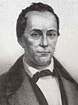 | 1 Jan 1851 - 31 Dec 1851 Martin J. Munzinger FDP  (b. 1791 - d. 1855)
1 Jan 1852 - 31 Dec 1852 Jonas Furrer
(2nd time) FDP (s.a.)
 | 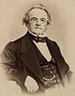 | 1 Jan 1853 - 31 Dec 1853 Wilhelm Matthias Näff FDP  (b. 1802 - d. 1881)
 | 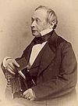 | 1 Jan 1854 - 31 Dec 1854 Friedrich Frey-Herosé  (1st time) FDP  (b. 1801 - d. 1873)
1 Jan 1855 - 31 Dec 1855 Jonas Furrer
(3rd time) FDP (s.a.)
 | 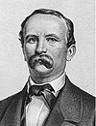 | 1 Jan 1856 - 31 Dec 1856 Jakob Stämpfli  (1st time) FDP  (b. 1820 - d. 1879)
 | 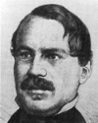 | 1 Jan 1857 - 31 Dec 1857 Constant Fornerod  (1st time) FDP  (b. 1819 - d. 1899)
1 Jan 1858 - 31 Dec 1858 Jonas Furrer
(4th time) FDP (s.a.)
1 Jan 1859 - 31 Dec 1859 Jakob Stämpfli
(2nd time) FDP (s.a.)
1 Jan 1860 - 31 Dec 1860 Friedrich Frey-Herosé
(2nd time) FDP (s.a.)
 | 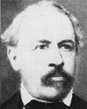 | 1 Jan 1861 - 31 Dec 1861 Melchior Josef Martin Knüsel  (1st time) FDP  (b. 1813 - d. 1889)
1 Jan 1862 - 31 Dec 1862 Jakob Stämpfli
(3rd time) FDP (s.a.)
1 Jan 1863 - 31 Dec 1863 Constant Fornerod
(2nd time) FDP (s.a.)
 | 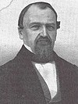 | 1 Jan 1864 - 31 Dec 1864 Jakob Dubs  (1st time) FDP (b. 1822 - d. 1879)
 | 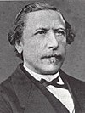 | 1 Jan 1865 - 31 Dec 1865 Karl Schenk  (1st time) FDP  (b. 1823 - d. 1895)
1 Jan 1866 - 31 Dec 1866 Melchior Josef Martin Knüsel
(2nd time) FDP (s.a.)
1 Jan 1867 - 31 Dec 1867 Constant Fornerod
(3rd time) FDP (s.a.)
1 Jan 1868 - 31 Dec 1868 Jakob Dubs
(2nd time) FDP (s.a.)
 | 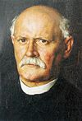 | 1 Jan 1869 - 31 Dec 1869 Emil Welti  (1st time) FDP  (b. 1825 - d. 1899)
1 Jan 1870 - 31 Dec 1870 Jakob Dubs
(3rd time) FDP (s.a.)
1 Jan 1871 - 31 Dec 1871 Karl Schenk
(2nd time) FDP (s.a.)
1 Jan 1872 - 31 Dec 1872 Emil Welti
(2nd time) FDP (s.a.)
 | 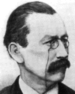 | 1 Jan 1873 - 31 Dec 1873 Paul Cérésole FDP (b. 1832 - d. 1905)
1 Jan 1874 - 31 Dec 1874 Karl Schenk
(3rd time) FDP (s.a.)
 | 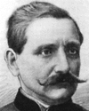 | 1 Jan 1875 - 31 Dec 1875 Johann Jakob Scherer FDP  (b. 1825 - d. 1878)
1 Jan 1876 - 31 Dec 1876 Emil Welti
(3rd time) FDP (s.a.)
 | 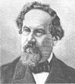 | 1 Jan 1877 - 31 Dec 1877 Joachim Heer FDP (b. 1825 - d. 1879)
1 Jan 1878 - 31 Dec 1878 Karl Schenk
(4th time) FDP (s.a.)
 | 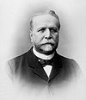 | 1 Jan 1879 - 31 Dec 1879 Bernhard Hammer  (1st time) FDP (b. 1822 - d. 1907)
1 Jan 1880 - 31 Dec 1880 Emil Welti
(4th time) FDP (s.a.)
 | 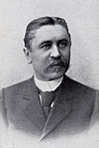 | 1 Jan 1881 - 31 Dec 1881 Numa Droz  (1st time) FDP (b. 1844 - d. 1899)
 | 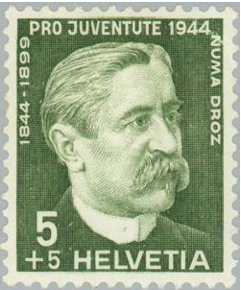
 | 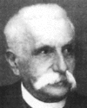 | 1 Jan 1882 - 31 Dec 1882 Simeon Bavier FDP (b. 1825 - d. 1896)
 | 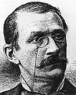 | 1 Jan 1883 - 31 Dec 1883 Louis Ruchonnet  (1st time) FDP (b. 1834 - d. 1893)
1 Jan 1884 - 31 Dec 1884 Emil Welti
(5th time) FDP (s.a.)
1 Jan 1885 - 31 Dec 1885 Karl Schenk
(5th time) FDP (s.a.)
 | 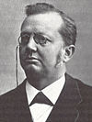 | 1 Jan 1886 - 31 Dec 1886 Adolf Deucher  (1st time) FDP (b. 1831 - d. 1912)
1 Jan 1887 - 31 Dec 1887 Numa Droz
(2nd time) FDP (s.a.)
 | 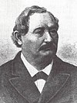 | 1 Jan 1888 - 27 Nov 1888 Wilhelm Friedrich Hertenstein FDP (b. 1825 - d. 1888)
27 Nov 1888 - 31 Dec 1889 Bernhard Hammer
(2nd time) FDP (s.a.)
(acting to 31 Dec 1888)
1 Jan 1890 - 31 Dec 1890 Louis Ruchonnet
(2nd time) FDP (s.a.)
1 Jan 1891 - 31 Dec 1891 Emil Welti
(6th time) FDP (s.a.)
 | 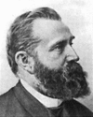 | 1 Jan 1892 - 31 Dec 1892 Walter Hauser  (1st time) FDP (b. 1837 - d. 1902)
1 Jan 1893 - 31 Dec 1893 Karl Schenk
(6th time)
FDP (s.a.)
 | 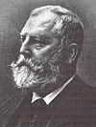 | 1 Jan 1894 - 31 Dec 1894 Emil Frey FDP  (b. 1838 - d. 1922)
 | 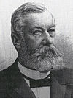 | 1 Jan 1895 - 31 Dec 1895 Joseph Zemp  (1st time) CVP (b. 1834 - d. 1908)
 | 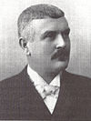 | 1 Jan 1896 - 31 Dec 1896 Adrien Lachenal FDP (b. 1849 - d. 1918)
 |  | 1 Jan 1897 - 31 Dec 1897 Adolf Deucher (2nd time) FDP (s.a.)
 | 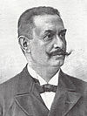 | 1 Jan 1898 - 31 Dec 1898 Eugène Ruffy FDP (b. 1854 - d. 1919)
 | 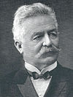 | 1 Jan 1899 - 31 Dec 1899 Eduard Müller  (1st time) FDP (b. 1848 - d. 1919)
1 Jan 1900 - 31 Dec 1900 Walter Hauser
(2nd time) FDP (s.a.)
 | 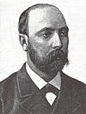 | 1 Jan 1901 - 31 Dec 1901 Ernst Brenner  (1st time) FDP (b. 1856 - d. 1911)
1 Jan 1902 - 31 Dec 1902 Joseph Zemp
(2nd time) CVP (s.a.)
1 Jan 1903 - 31 Dec 1903 Adolf Deucher
(3rd time) FDP (s.a.)
 | 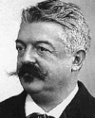 | 1 Jan 1904 - 31 Dec 1904 Robert Comtesse  (1st time) FDP (b. 1847 - d. 1922)
 | 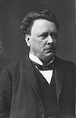 | 1 Jan 1905 - 31 Dec 1905 Marc-Émile Ruchet  (1st time) FDP (b. 1853 - d. 1912)
 | 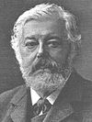 | 1 Jan 1906 - 31 Dec 1906 Ludwig Forrer  (1st time) FDP (b. 1845 - d. 1921)
1 Jan 1907 - 31 Dec 1907 Eduard Müller
(2nd time) FDP (s.a.)
1 Jan 1908 - 31 Dec 1908 Ernst Brenner
(2nd time) FDP (s.a.)
1 Jan 1909 - 31 Dec 1909 Adolf Deucher
(4th time) FDP (s.a.)
1 Jan 1910 - 31 Dec 1910 Robert Comtesse
(2nd time) FDP (s.a.)
1 Jan 1911 - 31 Dec 1911 Marc-Émile Ruchet
(2nd time) FDP (s.a.)
1 Jan 1912 - 31 Dec 1912 Ludwig Forrer
(2nd time) FDP (s.a.)
1 Jan 1913 - 31 Dec 1913 Eduard Müller
(3rd time) FDP (s.a.)
 | 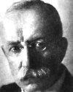 | 1 Jan 1914 - 31 Dec 1914 Arthur Hoffmann FDP (b. 1857 - d. 1927)
 | 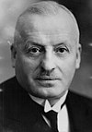 | 1 Jan 1915 - 31 Dec 1915 Giuseppe Motta  (1st time) CVP (b. 1871 - d. 1940)
 | 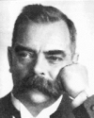 | 1 Jan 1916 - 31 Dec 1916 Camille Decoppet FDP (b. 1862 - d. 1925)
 | 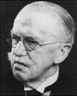 | 1 Jan 1917 - 31 Dec 1917 Edmund Schulthess  (1st time) FDP (b. 1868 - d. 1944)
 | 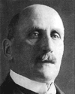 | 1 Jan 1918 - 31 Dec 1918 Felix Calonder FDP (b. 1863 - d. 1952)
 | 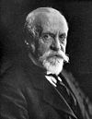 | 1 Jan 1919 - 31 Dec 1919 Gustave Ador LPS (b. 1845 - d. 1928)
1 Jan 1920 - 31 Dec 1920 Giuseppe Motta
(2nd time) CVP (s.a.)
1 Jan 1921 - 31 Dec 1921 Edmund Schulthess
(2nd time) FDP (s.a.)
 | 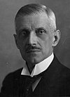 | 1 Jan 1922 - 31 Dec 1922 Robert Haab  (1st time) FDP (b. 1865 - d. 1939)
 | 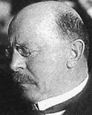 | 1 Jan 1923 - 31 Dec 1923 Karl Alfred Scheurer FDP (b. 1872 - d. 1929)
 | 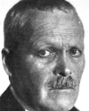 | 1 Jan 1924 - 31 Dec 1924 Ernest Chuard FDP (b. 1857 - d. 1942)
 | 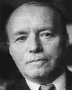 | 1 Jan 1925 - 31 Dec 1925 Jean-Marie Musy  (1st time) CVP (b. 1876 - d. 1952)
 | 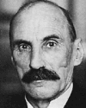 | 1 Jan 1926 - 31 Dec 1926 Heinrich Häberlin (  1st time) FDP (b. 1868 - d. 1947)
1 Jan 1927 - 31 Dec 1927 Giuseppe Motta
(3rd time) CVP (s.a.)
1 Jan 1928 - 31 Dec 1928 Edmund Schulthess
(3rd time) FDP (s.a.)
1 Jan 1929 - 31 Dec 1929 Robert Haab
(2nd time) FDP (s.a.)
1 Jan 1930 - 31 Dec 1930 Jean-Marie Musy
(2nd time) CVP (s.a.)
1 Jan 1931 - 31 Dec 1931 Heinrich Häberlin
(2nd time) FDP (s.a.)
1 Jan 1932 - 31 Dec 1932 Giuseppe Motta
(4th time) CVP (s.a.)
1 Jan 1933 - 31 Dec 1933 Edmund Schulthess
(4th time) FDP (s.a.)
 | 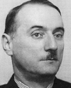 | 1 Jan 1934 - 31 Dec 1934 Marcel Pilet-Golaz  (1st time) FDP (b. 1889 - d. 1958)
 | 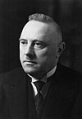 | 1 Jan 1935 - 31 Dec 1935 Rudolf Minger SVP (b. 1881 - d. 1955)
 | 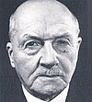 | 1 Jan 1936 - 31 Dec 1936 Albert Meyer FDP (b. 1870 - d. 1953)
1 Jan 1937 - 31 Dec 1937 Giuseppe Motta
(5th time) CVP (s.a.)
 | 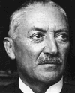 | 1 Jan 1938 - 31 Dec 1938 Johannes Baumann FDP (b. 1874 - d. 1953)
 | 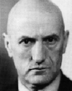 | 1 Jan 1939 - 31 Dec 1939 Philipp Etter  (1st time) CVP (b. 1891 - d. 1977)
 |  | 1 Jan 1940 - 31 Dec 1940 Marcel Pilet-Golaz (2nd time) FDP (s.a.)
 | 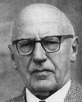 | 1 Jan 1941 - 31 Dec 1941 Ernst Wetter FDP (b. 1877 - d. 1965)
1 Jan 1942 - 31 Dec 1942 Philipp Etter
(2nd time) CVP (s.a.)
 | 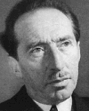 | 1 Jan 1943 - 31 Dec 1943 Enrico Celio (1st time) CVP (b. 1889 - d. 1980)
 | 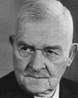 | 1 Jan 1944 - 31 Dec 1944 Walter Stampfli FDP (b. 1884 - d. 1965)
 | 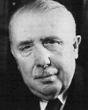 | 1 Jan 1945 - 31 Dec 1945 Eduard von Steiger  (1st time) SVP (b. 1881 - d. 1962)
 | 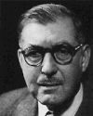 | 1 Jan 1946 - 31 Dec 1946 Karl Kobelt  (1st time) FDP (b. 1891 - d. 1968)
1 Jan 1947 - 31 Dec 1947 Philipp Etter
(3rd time) CVP (s.a.)
1 Jan 1948 - 31 Dec 1948 Enrico Celio
(2nd time) CVP (s.a.)
 | 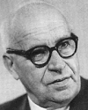 | 1 Jan 1949 - 31 Dec 1949 Ernst Nobs SPS (b. 1886 - d. 1957)
 |  | 1 Jan 1950 - 31 Dec 1950 Max Petitpierre (1st time) FDP (b. 1899 - d. 1994)
1 Jan 1951 - 31 Dec 1951 Eduard von Steiger
(2nd time) SVP (s.a.)
1 Jan 1952 - 31 Dec 1952 Karl Kobelt
(2nd time) FDP (s.a.)
1 Jan 1953 - 31 Dec 1953 Philipp Etter
(4th time) CVP (s.a.)
 | 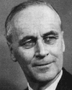 | 1 Jan 1954 - 31 Dec 1954 Rodolphe Rubattel FDP (b. 1896 - d. 1961)
 | 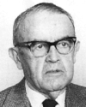 | 1 Jan 1955 - 31 Dec 1955 Max Petitpierre  (2nd time) FDP (s.a.)
 | 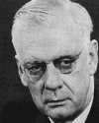 | 1 Jan 1956 - 31 Dec 1956 Markus Feldmann  SVP (b. 1897 - d. 1958)
 | 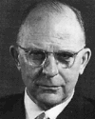 | 1 Jan 1957 - 31 Dec 1957 Hans Streuli  FDP (b. 1892 - d. 1970)
 | 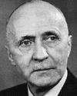 | 1 Jan 1958 - 31 Dec 1958 Thomas Holenstein  CVP (b. 1896 - d. 1962)
 | 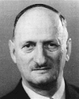 | 1 Jan 1959 - 31 Dec 1959 Paul Chaudet  (1st time) FDP (b. 1904 - d. 1977)
1 Jan 1960 - 31 Dec 1960 Max Petitpierre
(3rd time) FDP (s.a.)
 | 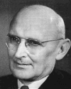 | 1 Jan 1961 - 31 Dec 1961 Friedrich Traugott Wahlen SVP (b. 1899 - d. 1985)
1 Jan 1962 - 31 Dec 1962 Paul Chaudet
(2nd time) FDP (s.a.)
 | 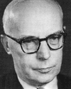 | 1 Jan 1963 - 31 Dec 1963 Willy Spühler  (1st time) SPS (b. 1902 - d. 1990)
 | 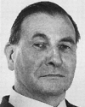 | 1 Jan 1964 - 31 Dec 1964 Ludwig von Moos  (1st time) CVP (b. 1910 - d. 1990)
 | 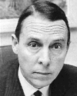 | 1 Jan 1965 - 31 Dec 1965 Hans Peter Tschudi  (1st time) SPS (b. 1913 - d. 2002)
1 Jan 1966 - 31 Dec 1966 Hans Schaffner
FDP (b. 1908 - d. 2004)
 | 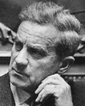 | 1 Jan 1967 - 31 Dec 1967 Roger Bonvin  (1st time) CVP (b. 1907 - d. 1982)
1 Jan 1968 - 31 Dec 1968 Willy Spühler
(2nd time) SPS (s.a.)
1 Jan 1969 - 31 Dec 1969 Ludwig von Moos
(2nd time) CVP (s.a.)
1 Jan 1970 - 31 Dec 1970 Hans Peter Tschudi
(2nd time) SPS (s.a.)
 | 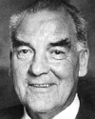 | 1 Jan 1971 - 31 Dec 1971 Rudolf Gnägi  (1st time) SVP (b. 1917 - d. 1985)
 | 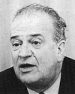 | 1 Jan 1972 - 31 Dec 1972 Nello Celio  FDP (b. 1914 - d. 1995)
1 Jan 1973 - 31 Dec 1973 Roger Bonvin
(2nd time) CVP (s.a.)
 | 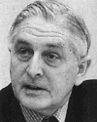 | 1 Jan 1974 - 31 Dec 1974 Ernst Brugger  FDP (b. 1914 - d. 1998)
 | 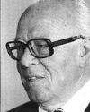 | 1 Jan 1975 - 31 Dec 1975 Pierre Graber  SPS (b. 1908 - d. 2003)
1 Jan 1976 - 31 Dec 1976 Rudolf Gnägi
(2nd time) SVP (s.a.)
 | 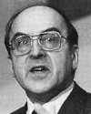 | 1 Jan 1977 - 31 Dec 1977 Kurt Furgler  (1st time) CVP (b. 1924 - d. 2008)
 | 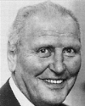 | 1 Jan 1978 - 31 Dec 1978 Willi Ritschard  SPS (b. 1918 - d. 1983)
 | 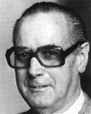 | 1 Jan 1979 - 31 Dec 1979 Hans Hürlimann  CVP (b. 1918 - d. 1994)
 | 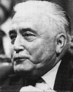 | 1 Jan 1980 - 31 Dec 1980 Georges-André Chevallaz FDP (b. 1915 - d. 2002)
1 Jan 1981 - 31 Dec 1981 Kurt Furgler
(2nd time) CVP (s.a.)
 | 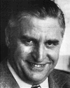 | 1 Jan 1982 - 31 Dec 1982 Fritz Honegger  FDP (b. 1917 - d. 1999)
 | 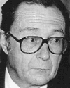 | 1 Jan 1983 - 31 Dec 1983 Pierre Aubert  (1st time) SPS (b. 1927 - d. 2016)
 | 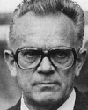 | 1 Jan 1984 - 31 Dec 1984 Leon Schlumpf  SVP (b. 1925 - d. 2012)
1 Jan 1985 - 31 Dec 1985 Kurt Furgler
(3rd time) CVP (s.a.)
 | 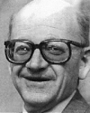 | 1 Jan 1986 - 31 Dec 1986 Alphons Egli  CVP (b. 1924 - d. 2016)
1 Jan 1987 - 31 Dec 1987 Pierre Aubert
(2nd time) SPS (s.a.)
 | 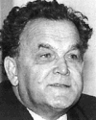 | 1 Jan 1988 - 31 Dec 1988 Otto Stich  (1st time) SPS (b. 1927 - d. 2012)
 | 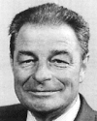 | 1 Jan 1989 - 31 Dec 1989 Jean-Pascal Delamuraz  (1st time) FDP (b. 1936 - d. 1998)
 | 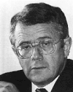 | 1 Jan 1990 - 31 Dec 1990 Arnold Koller  (1st time) CVP (b. 1933)
 | 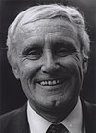 | 1 Jan 1991 - 31 Dec 1991 Flavio Cotti  (1st time) CVP (b. 1939)
 | 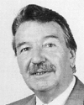 | 1 Jan 1992 - 31 Dec 1992 René Felber  SPS (b. 1933)
 | 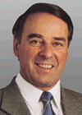 | 1 Jan 1993 - 31 Dec 1993 Adolf Ogi  (1st time) SVP (b. 1942)
1 Jan 1994 - 31 Dec 1994 Otto Stich
(2nd time) SPS (s.a.)
 | 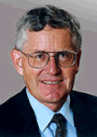 | 1 Jan 1995 - 31 Dec 1995 Kaspar Villiger  (1st time) FDP (b. 1941)
1 Jan 1996 - 31 Dec 1996 Jean-Pascal Delamuraz
(2nd time) FDP (s.a.)
1 Jan 1997 - 31 Dec 1997 Arnold Koller
(2nd time) CVP (s.a.)
1 Jan 1998 - 31 Dec 1998 Flavio Cotti
(2nd time) CVP (s.a.)
 | 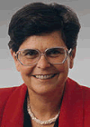 | 1 Jan 1999 - 31 Dec 1999 Ruth Dreifuss (f)  SPS (b. 1940)
1 Jan 2000 - 31 Dec 2000 Adolf Ogi
(2nd time) SVP (s.a.)
 | 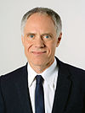 | 1 Jan 2001 - 31 Dec 2001 Moritz Leuenberger  (1st time) SPS (b. 1946)
1 Jan 2002 - 31 Dec 2002 Kaspar Villiger
(2nd time) FDP (s.a.)
 | 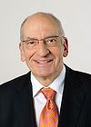 | 1 Jan 2003 - 31 Dec 2003 Pascal Couchepin  (1st time) FDP (b. 1942)
 | 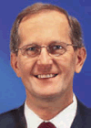 | 1 Jan 2004 - 31 Dec 2004 Joseph Deiss  CVP (b. 1946)
 | 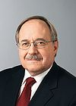 | 1 Jan 2005 - 31 Dec 2005 Samuel Schmid  SVP (b. 1947)
1 Jan 2006 - 31 Dec 2006 Moritz Leuenberger
(2nd time) SPS (s.a.)
 | 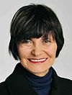 | 1 Jan 2007 - 31 Dec 2007 Micheline Calmy-Rey (f)  (1st time) SPS (b. 1945)
1 Jan 2008 - 31 Dec 2008 Pascal Couchepin
(2nd time) FDP (s.a.)
 | 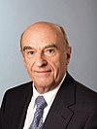 | 1 Jan 2009 - 31 Dec 2009 Hans-Rudolf Merz  FDP (b. 1942)
 | 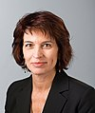 | 1 Jan 2010 - 31 Dec 2010 Doris Leuthard (f)  (1st time) CVP (b. 1963)
1 Jan 2011 - 31 Dec 2011 Micheline Calmy-Rey (f)
(2nd time) SPS (s.a.)
 | 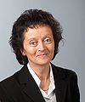 | 1 Jan 2012 - 31 Dec 2012 Eveline Widmer-Schlumpf (f) BDP (b. 1956)
 | 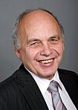 | 1 Jan 2013 - 31 Dec 2013 Ueli Maurer  (1st time)  SVP (b. 1950)
 | 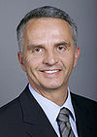 | 1 Jan 2014 - 31 Dec 2014 Didier Burkhalter  FDP (b. 1960)
 | 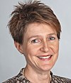 | 1 Jan 2015 - 31 Dec 2015 Simonetta Sommaruga (f) SPS (b. 1960)
 | 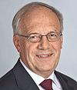 | 1 Jan 2016 - 31 Dec 2016 Johann Schneider-Ammann FDP (b. 1952)
1 Jan 2017 - 31 Dec 2017 Doris Leuthard (f)
(2nd time) CVP (s.a.)
 | 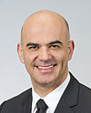 | 1 Jan 2018 - 31 Dec 2018 Alain Berset  SPS (b. 1972)
 | 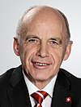 | 1 Jan 2019 - Ueli Maurer  (2nd time) SVP (s.a.)
 | 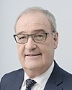
 | 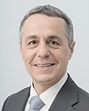
 | 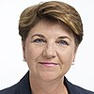
 |  | Party abbreviations: BDP=Civic Democratic Party of Switzerland, CVP=Christian Democratic People's Party (before 1912 Catholic Conservative Party, 1912-57 Swiss Conservative People's Party, 1957-70 Conservative Christian Social People's Party), FDP=Liberal-Democratic Party or predecessors, LPS=Liberal Party of Switzerland or predecessors, SPS=Social Democratic Party of Switzerland, SVP=Swiss People's Party (1921-71 Peasants', Business, and Citizens' Party)

INCLUDEPICTURE "http://t0.gstatic.com/images?q=tbn:ANd9GcTDT1jpfS6n_Y4NmsXFnf0dV2uAk854tEHeOSaIXPxUCt7qxHu5xaSaZA" \* MERGEFORMATINET INCLUDEPICTURE "http://t0.gstatic.com/images?q=tbn:ANd9GcTDT1jpfS6n_Y4NmsXFnf0dV2uAk854tEHeOSaIXPxUCt7qxHu5xaSaZA" \* MERGEFORMATINET INCLUDEPICTURE "http://t0.gstatic.com/images?q=tbn:ANd9GcTDT1jpfS6n_Y4NmsXFnf0dV2uAk854tEHeOSaIXPxUCt7qxHu5xaSaZA" \* MERGEFORMATINET INCLUDEPICTURE "http://t0.gstatic.com/images?q=tbn:ANd9GcTDT1jpfS6n_Y4NmsXFnf0dV2uAk854tEHeOSaIXPxUCt7qxHu5xaSaZA" \* MERGEFORMATINET INCLUDEPICTURE "http://t0.gstatic.com/images?q=tbn:ANd9GcTDT1jpfS6n_Y4NmsXFnf0dV2uAk854tEHeOSaIXPxUCt7qxHu5xaSaZA" \* MERGEFORMATINET INCLUDEPICTURE "http://t0.gstatic.com/images?q=tbn:ANd9GcTDT1jpfS6n_Y4NmsXFnf0dV2uAk854tEHeOSaIXPxUCt7qxHu5xaSaZA" \* MERGEFORMATINET INCLUDEPICTURE "http://t0.gstatic.com/images?q=tbn:ANd9GcTDT1jpfS6n_Y4NmsXFnf0dV2uAk854tEHeOSaIXPxUCt7qxHu5xaSaZA" \* MERGEFORMATINET INCLUDEPICTURE "http://t0.gstatic.com/images?q=tbn:ANd9GcTDT1jpfS6n_Y4NmsXFnf0dV2uAk854tEHeOSaIXPxUCt7qxHu5xaSaZA" \* MERGEFORMATINET INCLUDEPICTURE "http://t0.gstatic.com/images?q=tbn:ANd9GcTDT1jpfS6n_Y4NmsXFnf0dV2uAk854tEHeOSaIXPxUCt7qxHu5xaSaZA" \* MERGEFORMATINET INCLUDEPICTURE "http://t0.gstatic.com/images?q=tbn:ANd9GcTDT1jpfS6n_Y4NmsXFnf0dV2uAk854tEHeOSaIXPxUCt7qxHu5xaSaZA" \* MERGEFORMATINET INCLUDEPICTURE "http://t0.gstatic.com/images?q=tbn:ANd9GcTDT1jpfS6n_Y4NmsXFnf0dV2uAk854tEHeOSaIXPxUCt7qxHu5xaSaZA" \* MERGEFORMATINET INCLUDEPICTURE "http://t0.gstatic.com/images?q=tbn:ANd9GcTDT1jpfS6n_Y4NmsXFnf0dV2uAk854tEHeOSaIXPxUCt7qxHu5xaSaZA" \* MERGEFORMATINET INCLUDEPICTURE "http://t0.gstatic.com/images?q=tbn:ANd9GcTDT1jpfS6n_Y4NmsXFnf0dV2uAk854tEHeOSaIXPxUCt7qxHu5xaSaZA" \* MERGEFORMATINET INCLUDEPICTURE "http://t0.gstatic.com/images?q=tbn:ANd9GcTDT1jpfS6n_Y4NmsXFnf0dV2uAk854tEHeOSaIXPxUCt7qxHu5xaSaZA" \* MERGEFORMATINET INCLUDEPICTURE "http://t0.gstatic.com/images?q=tbn:ANd9GcTDT1jpfS6n_Y4NmsXFnf0dV2uAk854tEHeOSaIXPxUCt7qxHu5xaSaZA" \* MERGEFORMATINET INCLUDEPICTURE "http://t0.gstatic.com/images?q=tbn:ANd9GcTDT1jpfS6n_Y4NmsXFnf0dV2uAk854tEHeOSaIXPxUCt7qxHu5xaSaZA" \* MERGEFORMATINET INCLUDEPICTURE "http://t0.gstatic.com/images?q=tbn:ANd9GcTDT1jpfS6n_Y4NmsXFnf0dV2uAk854tEHeOSaIXPxUCt7qxHu5xaSaZA" \* MERGEFORMATINET INCLUDEPICTURE "http://t0.gstatic.com/images?q=tbn:ANd9GcTDT1jpfS6n_Y4NmsXFnf0dV2uAk854tEHeOSaIXPxUCt7qxHu5xaSaZA" \* MERGEFORMATINET INCLUDEPICTURE "http://t0.gstatic.com/images?q=tbn:ANd9GcTDT1jpfS6n_Y4NmsXFnf0dV2uAk854tEHeOSaIXPxUCt7qxHu5xaSaZA" \* MERGEFORMATINET INCLUDEPICTURE "http://t0.gstatic.com/images?q=tbn:ANd9GcTDT1jpfS6n_Y4NmsXFnf0dV2uAk854tEHeOSaIXPxUCt7qxHu5xaSaZA" \* MERGEFORMATINET INCLUDEPICTURE "http://t0.gstatic.com/images?q=tbn:ANd9GcTDT1jpfS6n_Y4NmsXFnf0dV2uAk854tEHeOSaIXPxUCt7qxHu5xaSaZA" \* MERGEFORMATINET INCLUDEPICTURE "http://t0.gstatic.com/images?q=tbn:ANd9GcTDT1jpfS6n_Y4NmsXFnf0dV2uAk854tEHeOSaIXPxUCt7qxHu5xaSaZA" \* MERGEFORMATINET INCLUDEPICTURE "http://t0.gstatic.com/images?q=tbn:ANd9GcTDT1jpfS6n_Y4NmsXFnf0dV2uAk854tEHeOSaIXPxUCt7qxHu5xaSaZA" \* MERGEFORMATINET INCLUDEPICTURE "http://t0.gstatic.com/images?q=tbn:ANd9GcTDT1jpfS6n_Y4NmsXFnf0dV2uAk854tEHeOSaIXPxUCt7qxHu5xaSaZA" \* MERGEFORMATINET INCLUDEPICTURE "http://t0.gstatic.com/images?q=tbn:ANd9GcTDT1jpfS6n_Y4NmsXFnf0dV2uAk854tEHeOSaIXPxUCt7qxHu5xaSaZA" \* MERGEFORMATINET INCLUDEPICTURE "http://t0.gstatic.com/images?q=tbn:ANd9GcTDT1jpfS6n_Y4NmsXFnf0dV2uAk854tEHeOSaIXPxUCt7qxHu5xaSaZA" \* MERGEFORMATINET INCLUDEPICTURE "http://t0.gstatic.com/images?q=tbn:ANd9GcTDT1jpfS6n_Y4NmsXFnf0dV2uAk854tEHeOSaIXPxUCt7qxHu5xaSaZA" \* MERGEFORMATINET INCLUDEPICTURE "http://t0.gstatic.com/images?q=tbn:ANd9GcTDT1jpfS6n_Y4NmsXFnf0dV2uAk854tEHeOSaIXPxUCt7qxHu5xaSaZA" \* MERGEFORMATINET INCLUDEPICTURE "http://t0.gstatic.com/images?q=tbn:ANd9GcTDT1jpfS6n_Y4NmsXFnf0dV2uAk854tEHeOSaIXPxUCt7qxHu5xaSaZA" \* MERGEFORMATINET INCLUDEPICTURE "http://t0.gstatic.com/images?q=tbn:ANd9GcTDT1jpfS6n_Y4NmsXFnf0dV2uAk854tEHeOSaIXPxUCt7qxHu5xaSaZA" \* MERGEFORMATINET INCLUDEPICTURE "http://t0.gstatic.com/images?q=tbn:ANd9GcTDT1jpfS6n_Y4NmsXFnf0dV2uAk854tEHeOSaIXPxUCt7qxHu5xaSaZA" \* MERGEFORMATINET INCLUDEPICTURE "http://t0.gstatic.com/images?q=tbn:ANd9GcTDT1jpfS6n_Y4NmsXFnf0dV2uAk854tEHeOSaIXPxUCt7qxHu5xaSaZA" \* MERGEFORMATINET INCLUDEPICTURE "http://t0.gstatic.com/images?q=tbn:ANd9GcTDT1jpfS6n_Y4NmsXFnf0dV2uAk854tEHeOSaIXPxUCt7qxHu5xaSaZA" \* MERGEFORMATINET INCLUDEPICTURE "http://t0.gstatic.com/images?q=tbn:ANd9GcTDT1jpfS6n_Y4NmsXFnf0dV2uAk854tEHeOSaIXPxUCt7qxHu5xaSaZA" \* MERGEFORMATINET INCLUDEPICTURE "http://t0.gstatic.com/images?q=tbn:ANd9GcTDT1jpfS6n_Y4NmsXFnf0dV2uAk854tEHeOSaIXPxUCt7qxHu5xaSaZA" \* MERGEFORMATINET INCLUDEPICTURE "http://t0.gstatic.com/images?q=tbn:ANd9GcTDT1jpfS6n_Y4NmsXFnf0dV2uAk854tEHeOSaIXPxUCt7qxHu5xaSaZA" \* MERGEFORMATINET INCLUDEPICTURE "http://t0.gstatic.com/images?q=tbn:ANd9GcTDT1jpfS6n_Y4NmsXFnf0dV2uAk854tEHeOSaIXPxUCt7qxHu5xaSaZA" \* MERGEFORMATINET INCLUDEPICTURE "http://t0.gstatic.com/images?q=tbn:ANd9GcTDT1jpfS6n_Y4NmsXFnf0dV2uAk854tEHeOSaIXPxUCt7qxHu5xaSaZA" \* MERGEFORMATINET INCLUDEPICTURE "http://t0.gstatic.com/images?q=tbn:ANd9GcTDT1jpfS6n_Y4NmsXFnf0dV2uAk854tEHeOSaIXPxUCt7qxHu5xaSaZA" \* MERGEFORMATINET INCLUDEPICTURE "http://t0.gstatic.com/images?q=tbn:ANd9GcTDT1jpfS6n_Y4NmsXFnf0dV2uAk854tEHeOSaIXPxUCt7qxHu5xaSaZA" \* MERGEFORMATINET INCLUDEPICTURE "http://t0.gstatic.com/images?q=tbn:ANd9GcTDT1jpfS6n_Y4NmsXFnf0dV2uAk854tEHeOSaIXPxUCt7qxHu5xaSaZA" \* MERGEFORMATINET INCLUDEPICTURE "http://t0.gstatic.com/images?q=tbn:ANd9GcTDT1jpfS6n_Y4NmsXFnf0dV2uAk854tEHeOSaIXPxUCt7qxHu5xaSaZA" \* MERGEFORMATINET INCLUDEPICTURE "http://t0.gstatic.com/images?q=tbn:ANd9GcTDT1jpfS6n_Y4NmsXFnf0dV2uAk854tEHeOSaIXPxUCt7qxHu5xaSaZA" \* MERGEFORMATINET INCLUDEPICTURE "http://t0.gstatic.com/images?q=tbn:ANd9GcTDT1jpfS6n_Y4NmsXFnf0dV2uAk854tEHeOSaIXPxUCt7qxHu5xaSaZA" \* MERGEFORMATINET INCLUDEPICTURE "http://t0.gstatic.com/images?q=tbn:ANd9GcTDT1jpfS6n_Y4NmsXFnf0dV2uAk854tEHeOSaIXPxUCt7qxHu5xaSaZA" \* MERGEFORMATINET INCLUDEPICTURE "http://t0.gstatic.com/images?q=tbn:ANd9GcTDT1jpfS6n_Y4NmsXFnf0dV2uAk854tEHeOSaIXPxUCt7qxHu5xaSaZA" \* MERGEFORMATINET INCLUDEPICTURE "http://t0.gstatic.com/images?q=tbn:ANd9GcTDT1jpfS6n_Y4NmsXFnf0dV2uAk854tEHeOSaIXPxUCt7qxHu5xaSaZA" \* MERGEFORMATINET INCLUDEPICTURE "http://t0.gstatic.com/images?q=tbn:ANd9GcTDT1jpfS6n_Y4NmsXFnf0dV2uAk854tEHeOSaIXPxUCt7qxHu5xaSaZA" \* MERGEFORMATINET INCLUDEPICTURE "http://t0.gstatic.com/images?q=tbn:ANd9GcTDT1jpfS6n_Y4NmsXFnf0dV2uAk854tEHeOSaIXPxUCt7qxHu5xaSaZA" \* MERGEFORMATINET INCLUDEPICTURE "http://t0.gstatic.com/images?q=tbn:ANd9GcTDT1jpfS6n_Y4NmsXFnf0dV2uAk854tEHeOSaIXPxUCt7qxHu5xaSaZA" \* MERGEFORMATINET INCLUDEPICTURE "http://t0.gstatic.com/images?q=tbn:ANd9GcTDT1jpfS6n_Y4NmsXFnf0dV2uAk854tEHeOSaIXPxUCt7qxHu5xaSaZA" \* MERGEFORMATINET INCLUDEPICTURE "http://t0.gstatic.com/images?q=tbn:ANd9GcTDT1jpfS6n_Y4NmsXFnf0dV2uAk854tEHeOSaIXPxUCt7qxHu5xaSaZA" \* MERGEFORMATINET INCLUDEPICTURE "http://t0.gstatic.com/images?q=tbn:ANd9GcTDT1jpfS6n_Y4NmsXFnf0dV2uAk854tEHeOSaIXPxUCt7qxHu5xaSaZA" \* MERGEFORMATINET INCLUDEPICTURE "http://t0.gstatic.com/images?q=tbn:ANd9GcTDT1jpfS6n_Y4NmsXFnf0dV2uAk854tEHeOSaIXPxUCt7qxHu5xaSaZA" \* MERGEFORMATINET INCLUDEPICTURE "http://t0.gstatic.com/images?q=tbn:ANd9GcTDT1jpfS6n_Y4NmsXFnf0dV2uAk854tEHeOSaIXPxUCt7qxHu5xaSaZA" \* MERGEFORMATINET INCLUDEPICTURE "http://t0.gstatic.com/images?q=tbn:ANd9GcTDT1jpfS6n_Y4NmsXFnf0dV2uAk854tEHeOSaIXPxUCt7qxHu5xaSaZA" \* MERGEFORMATINET INCLUDEPICTURE "http://t0.gstatic.com/images?q=tbn:ANd9GcTDT1jpfS6n_Y4NmsXFnf0dV2uAk854tEHeOSaIXPxUCt7qxHu5xaSaZA" \* MERGEFORMATINET INCLUDEPICTURE "http://t0.gstatic.com/images?q=tbn:ANd9GcTDT1jpfS6n_Y4NmsXFnf0dV2uAk854tEHeOSaIXPxUCt7qxHu5xaSaZA" \* MERGEFORMATINET INCLUDEPICTURE "http://t0.gstatic.com/images?q=tbn:ANd9GcTDT1jpfS6n_Y4NmsXFnf0dV2uAk854tEHeOSaIXPxUCt7qxHu5xaSaZA" \* MERGEFORMATINET INCLUDEPICTURE "http://t0.gstatic.com/images?q=tbn:ANd9GcTDT1jpfS6n_Y4NmsXFnf0dV2uAk854tEHeOSaIXPxUCt7qxHu5xaSaZA" \* MERGEFORMATINET INCLUDEPICTURE "http://t0.gstatic.com/images?q=tbn:ANd9GcTDT1jpfS6n_Y4NmsXFnf0dV2uAk854tEHeOSaIXPxUCt7qxHu5xaSaZA" \* MERGEFORMATINET INCLUDEPICTURE "http://t0.gstatic.com/images?q=tbn:ANd9GcTDT1jpfS6n_Y4NmsXFnf0dV2uAk854tEHeOSaIXPxUCt7qxHu5xaSaZA" \* MERGEFORMATINET INCLUDEPICTURE "http://t0.gstatic.com/images?q=tbn:ANd9GcTDT1jpfS6n_Y4NmsXFnf0dV2uAk854tEHeOSaIXPxUCt7qxHu5xaSaZA" \* MERGEFORMATINET INCLUDEPICTURE "http://t0.gstatic.com/images?q=tbn:ANd9GcTDT1jpfS6n_Y4NmsXFnf0dV2uAk854tEHeOSaIXPxUCt7qxHu5xaSaZA" \* MERGEFORMATINET INCLUDEPICTURE "http://t0.gstatic.com/images?q=tbn:ANd9GcTDT1jpfS6n_Y4NmsXFnf0dV2uAk854tEHeOSaIXPxUCt7qxHu5xaSaZA" \* MERGEFORMATINET INCLUDEPICTURE "http://t0.gstatic.com/images?q=tbn:ANd9GcTDT1jpfS6n_Y4NmsXFnf0dV2uAk854tEHeOSaIXPxUCt7qxHu5xaSaZA" \* MERGEFORMATINET INCLUDEPICTURE "http://t0.gstatic.com/images?q=tbn:ANd9GcTDT1jpfS6n_Y4NmsXFnf0dV2uAk854tEHeOSaIXPxUCt7qxHu5xaSaZA" \* MERGEFORMATINET INCLUDEPICTURE "http://t0.gstatic.com/images?q=tbn:ANd9GcTDT1jpfS6n_Y4NmsXFnf0dV2uAk854tEHeOSaIXPxUCt7qxHu5xaSaZA" \* MERGEFORMATINET INCLUDEPICTURE "http://t0.gstatic.com/images?q=tbn:ANd9GcTDT1jpfS6n_Y4NmsXFnf0dV2uAk854tEHeOSaIXPxUCt7qxHu5xaSaZA" \* MERGEFORMATINET INCLUDEPICTURE "http://t0.gstatic.com/images?q=tbn:ANd9GcTDT1jpfS6n_Y4NmsXFnf0dV2uAk854tEHeOSaIXPxUCt7qxHu5xaSaZA" \* MERGEFORMATINET INCLUDEPICTURE "http://t0.gstatic.com/images?q=tbn:ANd9GcTDT1jpfS6n_Y4NmsXFnf0dV2uAk854tEHeOSaIXPxUCt7qxHu5xaSaZA" \* MERGEFORMATINET INCLUDEPICTURE "http://t0.gstatic.com/images?q=tbn:ANd9GcTDT1jpfS6n_Y4NmsXFnf0dV2uAk854tEHeOSaIXPxUCt7qxHu5xaSaZA" \* MERGEFORMATINET INCLUDEPICTURE "http://t0.gstatic.com/images?q=tbn:ANd9GcTDT1jpfS6n_Y4NmsXFnf0dV2uAk854tEHeOSaIXPxUCt7qxHu5xaSaZA" \* MERGEFORMATINET INCLUDEPICTURE "http://t0.gstatic.com/images?q=tbn:ANd9GcTDT1jpfS6n_Y4NmsXFnf0dV2uAk854tEHeOSaIXPxUCt7qxHu5xaSaZA" \* MERGEFORMATINET INCLUDEPICTURE "http://t0.gstatic.com/images?q=tbn:ANd9GcTDT1jpfS6n_Y4NmsXFnf0dV2uAk854tEHeOSaIXPxUCt7qxHu5xaSaZA" \* MERGEFORMATINET INCLUDEPICTURE "http://t0.gstatic.com/images?q=tbn:ANd9GcTDT1jpfS6n_Y4NmsXFnf0dV2uAk854tEHeOSaIXPxUCt7qxHu5xaSaZA" \* MERGEFORMATINET INCLUDEPICTURE "http://t0.gstatic.com/images?q=tbn:ANd9GcTDT1jpfS6n_Y4NmsXFnf0dV2uAk854tEHeOSaIXPxUCt7qxHu5xaSaZA" \* MERGEFORMATINET INCLUDEPICTURE "http://t0.gstatic.com/images?q=tbn:ANd9GcTDT1jpfS6n_Y4NmsXFnf0dV2uAk854tEHeOSaIXPxUCt7qxHu5xaSaZA" \* MERGEFORMATINET

Compiler FLN

